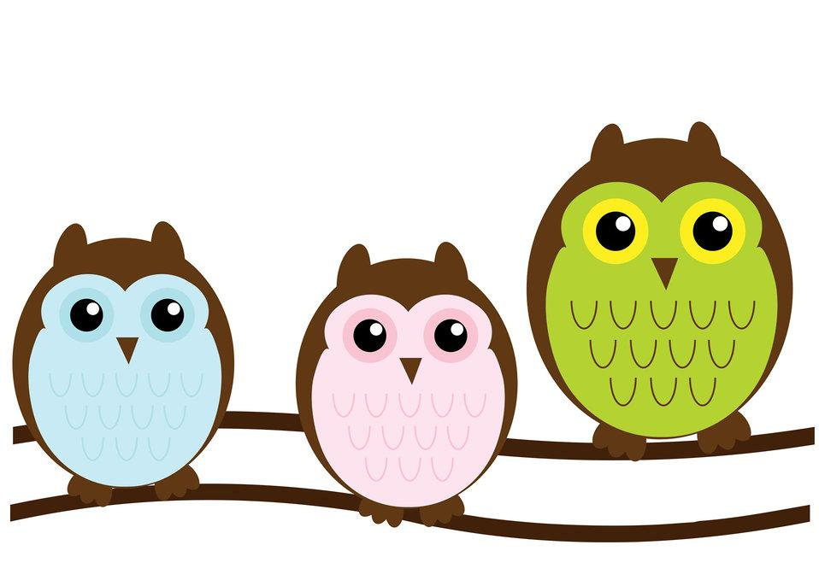 OWL ABOARD !

Miss. Smita, Kindergarten March 2025
Important dates:
- March 5th- Crazy hair/hat day
- March 17th- St. Patrick’s day
Wear green

Here’s what we’ll be learning:
Reading N Writing
- Hard C and Soft C
- Fiction and Nonfiction
- Continue compound words
- Comprehension- retelling and relating
- Word families

Math
- Numbers 1 -100
- Number Squeeze- Before and after
- Subtraction
- Money
- Number facts
Science
- Rainbows
- Force and Motion

Sight words:
do
go
little
had
stop
but
saw
how
them
your
ten

Letters of the month: Gg, Ww, Yy, Uu

A note from Miss. Smita:
February flew by and March is already here! As always Kindergarten is a busy place and will be for the rest of the year. Children are doing great in their sight words, numbers, reading and writing. Thank you for working with them with the homework and helping them learn and grow. Hope you enjoyed reading their space book.

Birthdays: Arthur - 3/30

